

**The UNT Faculty Information System (FIS)**

**Quick Start Guide**

What is the Faculty Information System? What can it do for me?

UNT’s Faculty Information System (FIS) is a resource for faculty and non-faculty alike. Students can use it to access information about their professors, such as:

* Contact information and office location
* Curriculum Vitae
* Areas of specialty
* Publications
* List of classes taught
* Syllabi for each class taught

Professors and administrators can use FIS for collaboration purposes and knowledge sharing, as well as an interface to meet Texas State standards for public universities, to ensure transparency and compliance with State guidelines.

Accessing the System – For Students and The Public

For general, public-facing access, go to www.facultyinfo.unt.edu.

The search box in the center of the page is easy to use; just be sure to set the gray drop-down box for the type of information you want to look up. It will be set on default to Faculty Name, but can be changed to search for Department or Courses.

The search will auto-fill as soon as you have input a first or last name, or have begun to type a course number or name.

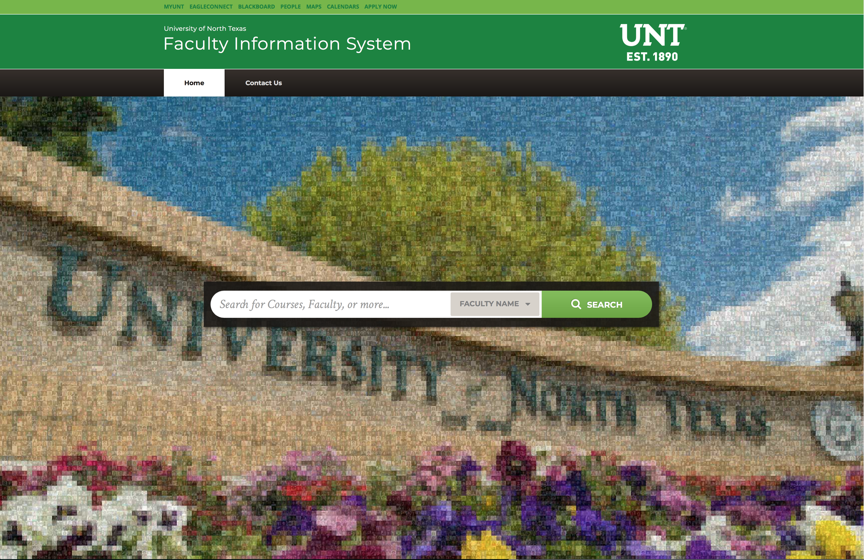

On a faculty member’s page, navigate the two tabs to see the faculty member’s CV, Education, and Currently scheduled teaching, as well as a list of previous classes taught and the links to download corresponding syllabi.

If you’ve searched for a course, the site will navigate to a page listing the professors who have taught it, in reverse chronological order, with most recent on top. Click any professor’s name to navigate to their faculty page.

Accessing the System – For Faculty and Administrators

Access the FIS internally via the my.unt.edu portal using the following steps:

1. Log in to my.unt.edu.
2. Click on the Faculty tab at the top middle of the page.
3. In the Digital Measures box to the right of your schedule, click on the Faculty Information System link. Your browser must allow pop-ups to access this feature. If you don’t have pop-ups enabled:
   1. For Windows users, select the Tools button, then click Internet Options. Choose the Privacy tab, then de-select the box labeled “Turn on Pop-Up Blocker” and click OK.
   2. For Safari users: on the Safari menu, choose Preferences, then select the Security tab. Click to de-select the box labeled “Block pop-up windows.”

1. Log in to my.unt.edu.

2. Click on the “Faculty” tab at the top.

3. In the “Digital Measures” box to the right of your schedule, click on the “Faculty Information System” link. (Note: your browser must allow pop-ups to access this feature.)

4. In the window that opens, scroll down to the second section, “Teaching,” and click “Scheduled Teaching.”

5. Select the appropriate course (the most recent courses are listed at the top).

6. At the bottom of the page, next to “Syllabus for this course No File Stored” click the button, Choose File.

7. Browse your computer to choose the file. Once you have done so, instead of “No File Stored,” you should see a link in green with your syllabus’ file name.

8. Once you have ensured your syllabus is there, click the “SAVE” button at the top right of the page. It is now safe to close the page.